
NOTICE OF MEETING

ACTON TRUSSELL, BEDNALL & TEDDESLEY HAY PARISH COUNCIL

Annual Parish Assembly
Wednesday 21st May 2025 – 8.00pm
at Acton Trussell Community Centre

AGENDA

- Apologies
- Chairman's Report
- Minutes of last Parish Meeting 22nd May 2024
- Finance
- District Councillors Report
- County Councillors Report
- Community Centre report
- Discussions:
Village Issues

This meeting will be followed by the ANNUAL PARISH COUNCIL MEETING

This is a PUBLIC meeting and you are invited to attend.
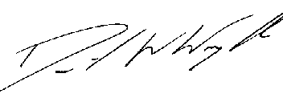
Clerk: D W Wright
15 Brindley Bank Road
Rugeley WS15 2EY
01889 441049
14 May 2024
actontrussell.clerk@yahoo.co.uk

Websites!!!! www.actontrussell-pc.gov.uk and www.batth.co.uk

