
NOTICE OF MEETING

ACTON TRUSSELL, BEDNALL & TEDDESLEY HAY PARISH COUNCIL

Annual Parish Council Meeting
Wednesday 21st May 2025 – 8.00pm
or after the Annual Parish Assembly
at Acton Trussell Community Centre

AGENDA

- To elect a Chairman
- To receive the Chairman’s declaration of office
- To elect a Vice-Chairman
- Apologies
- Declarations of Interest
- Minutes
To approve the minutes of the meeting of 16th April 2025 and to consider matters arising
a) Car Park at Bednall
b) Neighbourhood Plan
c) District Plan
- County Councillor’s Report
- District Councillor’s Report
- Parish Plan -Action list review including
- Community Activities -Community Centre & Recreation Field
- Communications -Website -Newsletter
- Environment -Climate Change
- Highways & transport
- Finance
- To receive a report on the Accounts for the year to date
- To approve accounts for payment
- Planning
- To report on Planning decisions
- To discuss current Planning Applications and confirm responses
- To receive and consider items of correspondence
- Reports from Councillors
- Risks

This is a PUBLIC meeting and you are invited to attend.
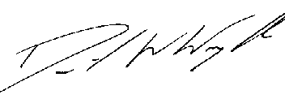
Clerk: D W Wright
15 Brindley Bank Road
Rugeley
WS15 2EY
01889 441049

12th May 2025 actontrussell.clerk@yahoo.co.uk

